OLTP Bikes R Us System
Bikes R US® Inc. would like to convert their manual Management System into a set of computerized subsystems that will allow employees to manage various aspects of the business via the Internet. Independent consultants are invited to propose new design elements for the existing system to meet the subsystem objectives outlined below.
Note: The specifications in this document are subject to change. Your instructor will notify you on any updates to this lab.

Integration
The business system will eventually consist of subsystem components which are to be developed over time. Since this is a new computerized system, a consistent presentation style is desirable. This phase of the system development will create a number of web pages for Online Transaction Processing that will allow:
- Employees to enter retail sales and returns.
- Management of part ordering and receiving.

Lab Objectives

This lab is to be built as an ASP.NET website solution. In this lab, you must demonstrate your ability to

Create SQL script files for stored procedures (implicit and/or explicit transactions)

Implement Enterprise Level Transaction processing

Implement Website Login Security based on ASP.NET Universal Providers

Use a Distributed Version Control System (DVCS) as a team project

Application Requirements
Analysis by Bikes R US® Inc. has revealed the need for many online transaction systems. These systems cover sales/returns of merchandise, ordering of merchandise and tracking the repair services offered on customer bikes.
This project will cover the need for sales/returns and purchasing. Each system is outlined in this document. The systems are to be developed concurrently. Your instructor will act as the Bikes R US official to provide clarification details for your project.
In discussion with Bikes R US officials, all web pages are to be been designed in a consistent functional fashion.
There are 4 main functional processes within each subsystem:
- Collection of data using online transaction processing techniques.
- Accumulative display of collected data.
- Allow for adjustments of the collected data.
- Process the final processing of the data within an enterprise transaction to the database.

Milestone Evaluations
To ensure an acceptable system is produced, the following milestones are to be met:
- Form images/mockups and use case descriptions are due on Oct 31/Nov 1, 2013 at class time.
  - The images must show sample data from the database.
- The use cases are to include a statement of purpose and indicate inputs and outputs. You will probably need to do a sequence diagram for the Enterprise Level Transaction process to get all of the cases requiring access to the database. A use case is any call that involves access to the library and/or the database. This diagram does not need to be submitted.
The following example demonstrates the type of description you are to supply for each use case. The example shows the use case name followed by a brief description.
LookupAnItem
LookupAnItem receives one parameter representing the Item number (integer). The system returns the complete Item record.
These documents will be reviewed and returned to each group with any suggested improvements or omissions. Inappropriate submissions (hand drawn or written) will not be acceptable. Failure to meet the milestone will result in a 10% project penalty against the group member those work was not submitted.

Lab Deliverables
The lab must be submitted by Dec 9, 2013 at 8:00 am in the DropBox on the P:/ drive. Each student must submit their own copy of the merged lab solution in their own DropBox folder. You must ensure that you have merged your work before submitting your lab; do not perform any modifications of your code after you have performed your final merge.
The final merge must be “tagged” as your lab submission in your DVCS. Use your team name and the version number “01.00.00.RC.” as your tag. For example, if you are Team Z, then your final merged version must be tagged as “01.00.00.RC.Team Z”.

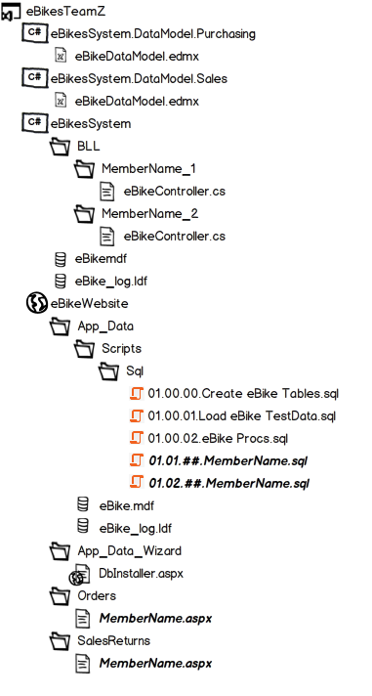
Team Work and Project Structure

Version Control
Because this project involves team work and parallel development, you will need to use a DVCS during your development. Commits of your individual code should occur regularly (at least every day that you perform any coding on your project). Merging your work should occur at least once or twice a week, so that you remain informed of each other’s progress and so that you have a common code base.
To help prevent merging conflicts, you should use a partial class for the BLL controller/manager. That way, you can each contribute code to the BLL through your own, separate class files.

Solution Structure
Your team will be assigned a team name (e.g.: Team Z), which you will use as the folder name for your project’s solution. Your project’s file and folder structure should resemble the sketch to the right.

This is a third semester group project which implies a certain level of technical and interpersonal competence. Marks can, and will, be deducted on the basis of not meeting your individual responsibilities as well as any failures in the group’s responsibilities. This is not an easy project; it will require the full attention of all group members from the start.

Order Subsystem. (Group member 1)
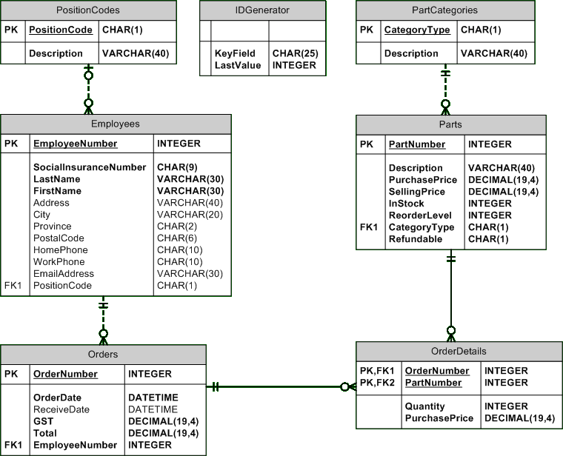
The ordering of merchandise is done by a store manager (or appointed employee). An order is place with a single vendor. We do not track vendor data.
The order process starts by requesting a suggested purchase order list from the database. The system compares inventory reorder levels against quantity on hand and outstanding purchase orders not yet received. This data, called the suggested order list, is displayed for the manager. The manager may then make any alternations to the suggested order list. The manager may add items to the suggested order list; adjust existing data on the list and remove items from the list. Once the manager is satisfied with the suggested order list, the purchase order is placed.
Delivery of the ordered merchandise occurs 3 to 30 days later. When an order is delivered, a store employee displays all outstanding orders for the store. The appropriate order is selected from the list and the order and its detail data are displayed. A manual check is done by the employee against this display. If all order merchandise is present, the employee receives the order and the items are placed into the store’s stock.
The collection, adjustment and display of product items being purchased for resale by Bikes R US® Inc. must include the following functionality:
- Create a suggested purchase order list from the current inventory item levels and quantity already on order versus the part’s reorder level. You will also need to check the inventory (Parts) for items that need to be ordered in case they not currently on order. Inventory item selection for this list is based on the following:
ReOrderLevel – (InStock + number of units on order) > 0
The number of units on order is be obtained by summing the part’s quantity in the OrderDetails for orders that have not been received but ordered (OrderDate exists and ReceiveDate is null). A view has been created for you called: UnitsOnOrder. (Hint: Views can be used in a query just like a table.)
Each part on the order list should display its partnumber, description, purchaseprice, current quantity in stock, current quantity on order (from the View), reorder level, and suggested order quantity (SOQ). The SOQ is calculated using:
SOQ = ReOrderLevel – (InStock + number of units on order)
- Add a part and order quantity to the suggested order list that is not on the original suggested order list. The employee should be able to lookup an item within the stock and view (at least) the part number, description, purchase price, current quantity on hand, and reorder level during the add process. This will allow the employee to review the item prior to adding it to order list. You should allow searching to be done by the part number, by the partial part description or by category.
- Cumulative totals (subtotal, taxes, and grand total) must be maintained as items are added, removed or altered to/from/on the collection and display on the form.
- Each part on the order list should be editable for purchase price and suggested order quantity.
- Each individual part should be able to be removed from the cart.
- The final processing of the order must be done using the Enterprise Level Transaction technique discussed in class. This processing must not be done unless there is at least one part item is present.
The receiving of outstanding orders for Bikes R US® Inc. must include the following functionality:
- Retrieval/display of all outstanding orders (only those with no receive date) showing order number, order date and total cost.
- Selection of a specific order (from the list above) results in the display of the complete purchase order record data and its corresponding purchase order detail data.
- Receive the displayed order adjusting the order receive date and update of the inventory item Quantity on hand. This should be done as a single transaction using an Enterprise Level transaction or an SQL explicit transaction.
Sales/Returns Subsystem. (Group member 2)
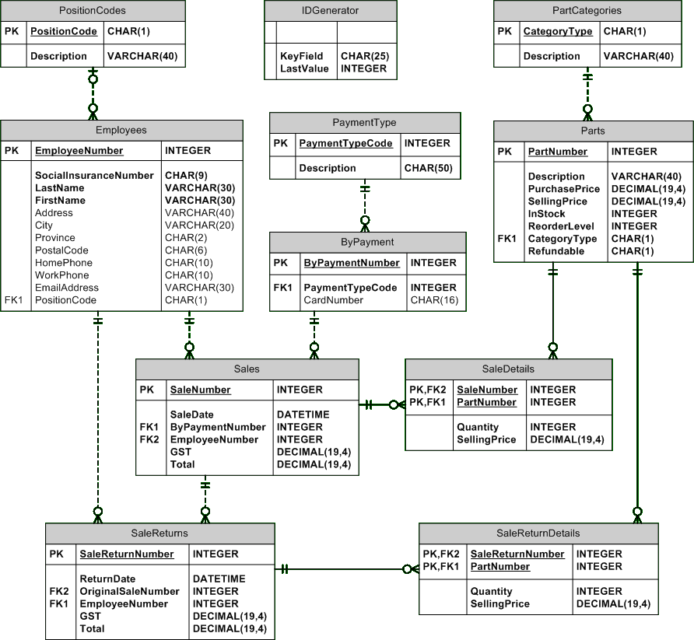
The sales process starts with a customer approaching the checkout counter with their desired merchandise items from the store shelves. For larger parts, the item will be listed on an order sheet which the clerk can use to enter the necessary information about the sale. The clerk will scan each item and have the item information displayed on the screen. If the item does not scan, the clerk should be able to enter a stock number or a description (partial) of the item and select from the list the correct item. Each merchandise item is listed once on the screen display with the appropriate identifying data and stock information. The clerk should enter the quantity to be purchased (default can be 1). As the sale is processed, a list must be displayed on the terminal consisting of the part number, description, selling price and quantity being purchased. Each item should appear only once on this list. The customer can pay using a debit, credit card or cash.
The return process starts with a customer approaching the customer service counter with the returning item(s) and the original sales receipt. NO returns are done without the original sales receipt. The clerk will enter the sale number on the receipt and display a list of items already returned (this list will be empty if no items have been previously returned, but should display a message of “No previous returns on this sale”). This list should display the return date, stock number, description, selling price and quantity returned.
The system will also display another list of items on the original sales receipt that have not been returned (effectively, the original sales receipt without the returned items). The list of items that can be returned should display the stock number, description, selling price, remaining quantity that can be returned, and quantity actually being returned. The quantity actually being returned should be editable. The clerk will then enter the quantity for each item to be returned. The number of items being returned cannot be greater than the number originally. Funds are returned to the source of payment.
Sales and returns are done as single transactions respectively.
The collection, adjustment and display of part items being sold by Bikes R US® Inc. must include the following functionality:
- The employee should be able to enter a part number and quantity to be added to the current sale list. The current sale list should display its part number, description, selling price and the quantity sold. The employee should have access to a part list which will display part information (part number, description, current in stock quantity and selling price). The employee should be able to select a specific part from the list (by partial part description or category) or enter a part number directly. Sale parts are not to be confused with parts used within the repair portion of our business.
- Accumulative totals (subtotal, taxes, and grand total) must be maintained as items are added, altered or removed to/on/from the collection.
- Each part on the sales list should be editable for selling price and sales quantity.
- Each individual part should be able to be removed from the sales list.
- The final processing of the sale must be done using the Enterprise Level Transaction technique discussed in class. This processing must not be done unless there is at least one product item is present. Ensure you adjust (decrease) the part in stock quantity during the process.
- A sale may be done by cash, debit or credit card. You must collect the debit or credit card number from the purchaser. You must check that the debit or credit card value is between 12 and 16 numeric digits. Record your sale payment method in the ByPayment table.
The collection, adjustment and display of part items being returned to Bikes R US® Inc. must include the following functionality:
- The employee is to enter the original sales number from the sales receipt.NO returns are done without the original sales receipt. Display all current returns for the receipt showing the return date, stock number, description, selling price and quantity returned.
- The list of items that can be returned should display the stock number, description, selling price, remaining quantity that can be returned, and quantity actually being returned. The quantity actually being returned should be editable.
- The final processing of the sale return must be done using the Enterprise Level Transaction technique discussed in class. This processing must not be done unless there is at least one part item is present. Ensure you adjust (increase) the part in stock quantity during the process.
- A summary of the completed return must be displayed, showing the return date, stock number, description, selling price and quantity returned. Accumulative totals (subtotal, taxes, and grand total) must also be shown.

